41.35: a) If normalized, then
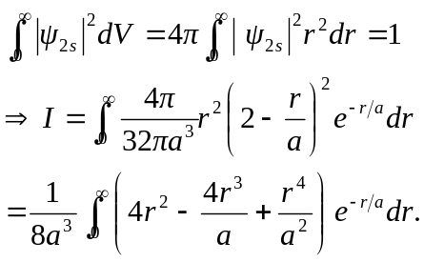
But recall 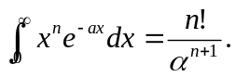
So 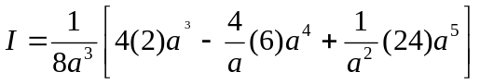
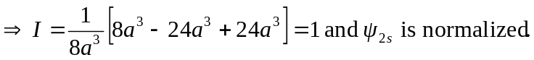
b) We carry out the same calculation as part (a) except now the upper limit on the integral is 4a, not infinity.
So 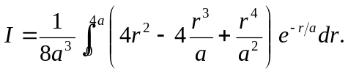
Now the necessary integral formulas are:
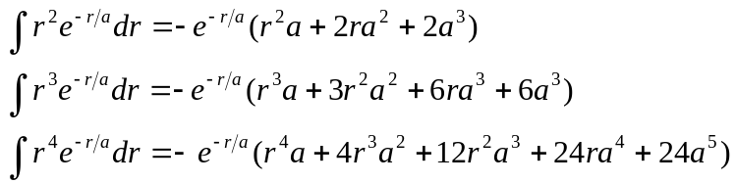
All the integrals are evaluated at the limits 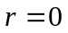and 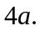 After carefully plugging in the limits and collecting like terms we have:
